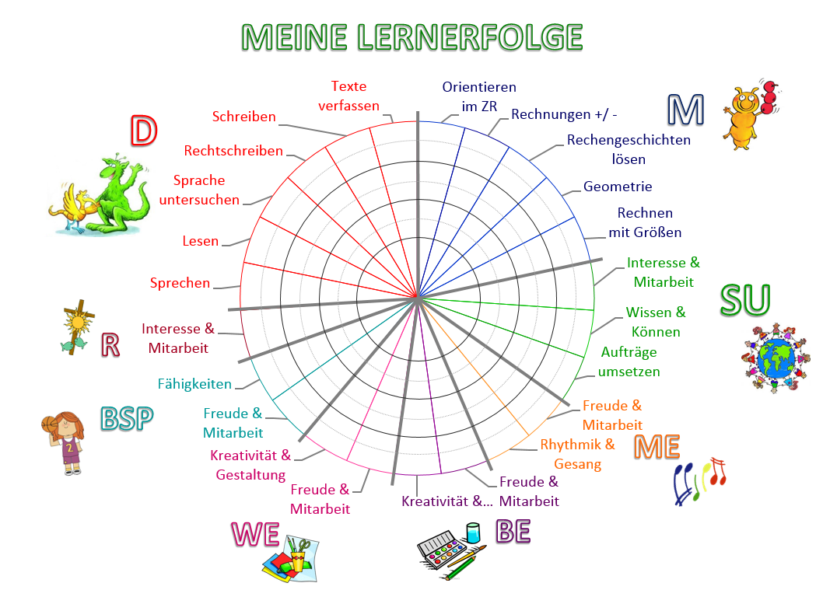NAME:________________________________ _________ KLASSE:____________________ DATUM:_______________________

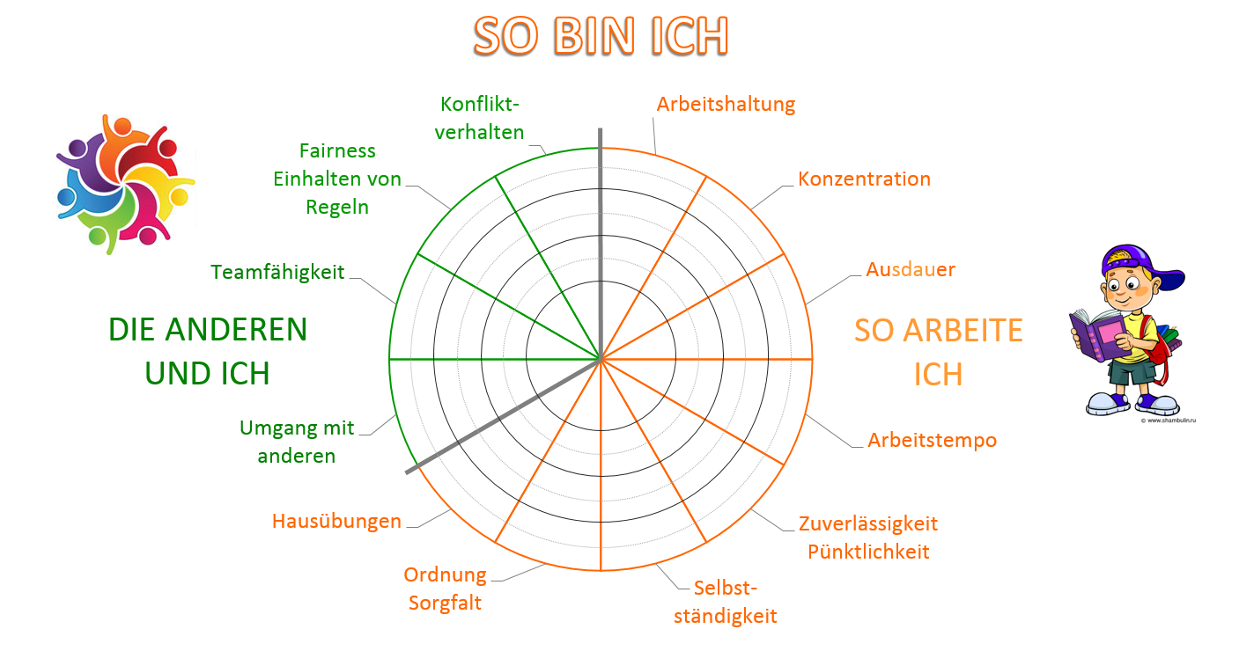

NAME:________________________________ _________ KLASSE:____________________ DATUM:_______________________

